**Experiment 1 Report**

1. **An explanation of the experiment (including parameters used)**

|  |  |
| --- | --- |
| *population size:* | *100* |
| *mutation rate:* | *0.5%* |
| *crossover method:* | *false* |
| *chromosome length:* | *100* |
| *selection method:* | *Truncation* |
| *max generations:* | *500* |
| *elitism:* | *10%* |
| *fitness method:* | *Smiley Face* |

1. **A hypothesis (might just be a guess)**

It will terminate around 300 generations and will increase slowly over time.

1. **Description of the results including plots (or a table of results)**

The graph increases similar to y=sqrt(x). There is a solution.

|  |  |  |  |  |  |  |  |  |  |  |
| --- | --- | --- | --- | --- | --- | --- | --- | --- | --- | --- |
| run # | 1 | 2 | 3 | 4 | 5 | 6 | 7 | 8 | 9 | 10 |
| gens | 280 | 290 | 270 | 275 | 280 | 300 | 310 | 260 | 270 | 280 |

1. **What if anything you can conclude and anything you learned or affirmed by doing so?**

The mutation rate has to be small enough for the best fitness to reach 100, in this case, 0.5% is a good mutation rate. Otherwise, when the fitness is close to perfect, a large mutation rate can cause the chromosomes to “over mutate,” changing itself too much that it deviates from the ideal chromosome again.

**Experiment 2 Report**

1. **An explanation of the experiment (including parameters used)**

|  |  |
| --- | --- |
| *population size:* | *100* |
| *mutation rate:* | *0.5%* |
| *crossover method:* | *true* |
| *chromosome length:* | *100* |
| *selection method:* | *Truncation* |
| *max generations:* | *500* |
| *elitism:* | *10%* |
| *fitness method:* | *Smiley Face* |

1. **A hypothesis (might just be a guess)**

It will terminate around 200 generations and will increase slowly over time.

1. **Description of the results including plots (or a table of results)**

The result appears almost identical to the trials without crossover. The fitness still increases at a decreasing rate but eventually reaches a best fitness of 100 around 200 to 300 generations.

|  |  |  |  |  |  |  |  |  |  |  |
| --- | --- | --- | --- | --- | --- | --- | --- | --- | --- | --- |
| run # | 1 | 2 | 3 | 4 | 5 | 6 | 7 | 8 | 9 | 10 |
| gens | *305* | *270* | *270* | *275* | *275* | *300* | *280* | *290* | *255* | *280* |

1. **What if anything you can conclude and anything you learned or affirmed by doing so?**

The crossover feature does not seem to contribute much to evolving the chromosomes to 100% fitness in the setting that we have. Since it is only splicing the parents to create the children, the likelihood that this action can push the chromosomes closer to the ideal one is very low in this case.

**Experiment 3 Report**

1. **An explanation of the experiment (including parameters used)**

|  |  |
| --- | --- |
| *population size:* | *100* |
| *mutation rate:* | *0%* |
| *crossover method:* | *true* |
| *chromosome length:* | *100* |
| *selection method:* | *Truncation* |
| *max generations:* | *500* |
| *elitism:* | *10%* |
| *fitness method:* | *Smiley Face* |

1. **A hypothesis (might just be a guess)**

It will not reach a fitness of 100 within 500 generations.

1. **Description of the results including plots (or a table of results)**

The best fitness chromosome stays constant. The worst and average fitness increases for a little bit at the beginning before reaching a constant value that they stay in until the end. Diversity also decreases a little bit at the beginning and reaches a constant value.

|  |  |  |  |  |  |  |  |  |  |  |
| --- | --- | --- | --- | --- | --- | --- | --- | --- | --- | --- |
| run # | 1 | 2 | 3 | 4 | 5 | 6 | 7 | 8 | 9 | 10 |
| gens | *500* | *500* | *500* | *500* | *500* | *500* | *500* | *500* | *500* | *500* |

1. **What if anything you can conclude and anything you learned or affirmed by doing so?**

This experiment isolates the contributions made by crossover. The slight increase in worst and average fitness and the slight decrease in diversity shows that crossover is contributing a little bit to the population evolving into the ideal chromosome. However, crossover has a limit to how much it can contribute to the evolution as all four displayed values reaches a constant value in the long run.

**Experiment 4 Report**

1. **An explanation of the experiment (including parameters used)**

|  |  |
| --- | --- |
| *population size:* | *100* |
| *mutation rate:* | *0.5%* |
| *crossover method:* | *false* |
| *chromosome length:* | *100* |
| *selection method:* | *Best Random Worst* |
| *max generations:* | *500* |
| *elitism:* | *10%* |
| *fitness method:* | *Smiley Face* |
| *Original Generation:* | *Worst case,*  *direct opposite of the ideal chromosome* |

1. **A hypothesis (might just be a guess)**

The selection method will be able to evolve an ideal chromosome before reaching the 500th generation.

1. **Description of the results including plots (or a table of results)**

While the best fitness is able to reach 100% fitness from the worst case scenario, the worst fitness actually decreases in its fitness score and stays at 0.

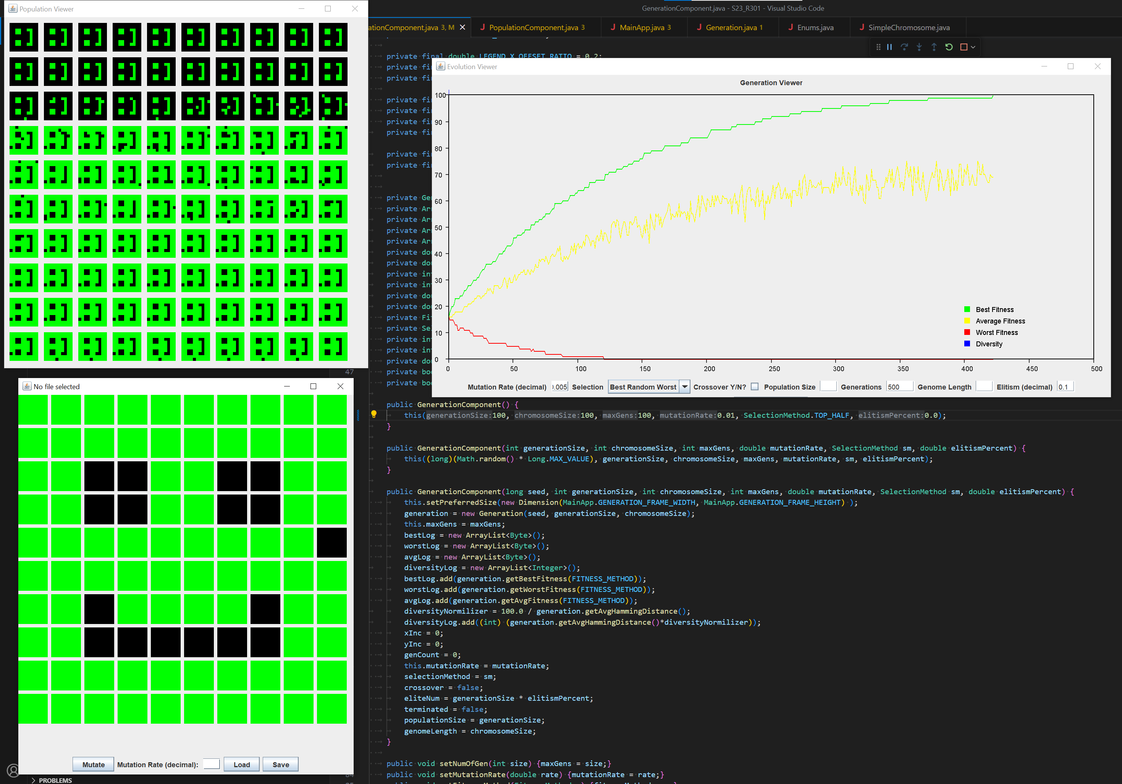

|  |  |  |  |  |  |  |  |  |  |  |
| --- | --- | --- | --- | --- | --- | --- | --- | --- | --- | --- |
| run # | 1 | 2 | 3 | 4 | 5 | 6 | 7 | 8 | 9 | 10 |
| gens | *453* | *469* | *432* | *450* | *415* | *480* | *462* | *420* | *480* | *492* |

1. **What if anything you can conclude and anything you learned or affirmed by doing so?**

The best random worst method, designed to navigate troughs in a fitness landscape, cannot evolve its worst fitness towards the ideal chromosome. This is the trade off it has between navigating troughs and evolving the entire population.

**Experiment 5 Report**

1. **An explanation of the experiment (including parameters used)**

|  |  |
| --- | --- |
| *population size:* | *100* |
| *mutation rate:* | *0.5%* |
| *crossover method:* | *false* |
| *chromosome length:* | *100* |
| *selection method:* | *Truncation* |
| *max generations:* | *500* |
| *elitism:* | *10%* |
| *fitness method:* | *decreasing significance* |

1. **A hypothesis (might just be a guess)**

The most significant bits of the genome of the population will be 1s while the least significant bits will vary.

1. **Description of the results including plots (or a table of results)**

The graph increases similar to y=sqrt(x). There is not a solution.

|  |  |  |  |  |  |  |  |  |  |  |
| --- | --- | --- | --- | --- | --- | --- | --- | --- | --- | --- |
| run # | 1 | 2 | 3 | 4 | 5 | 6 | 7 | 8 | 9 | 10 |
| gens | *500* | *500* | *500* | *500* | *500* | *500* | *500* | *500* | *500* | *500* |

1. **What if anything you can conclude and anything you learned or affirmed by doing so?**

It is very difficult to reach 100% fitness when the significance of each gene varies drastically. We assumed that the entire population would have the most significant genes be set and the genes of lower significance be varied which is what we saw.  
*[replace me!* Each generation could still have a very poor performing agent according to these results. Fitness is not automatically increasing across the entire population from one generation to the next, some may do worse.]

**Experiment 6 Report**

1. **An explanation of the experiment (including parameters used)**

|  |  |
| --- | --- |
| *population size:* | *100* |
| *mutation rate:* | *0.5%* |
| *crossover method:* | *false* |
| *chromosome length:* | *100* |
| *selection method:* | *Best Random Worst* |
| *max generations:* | *500* |
| *elitism:* | *10%* |
| *fitness method:* | *Troughs* |

1. **A hypothesis (might just be a guess)**

It will not terminate and will get stuck around 70% fitness.

1. **Description of the results including plots (or a table of results)**

The best and average fitness increases in steps, and between each step, there are plateaus of zero growth for an increasing amount of time as the evolution continues. The worst fitness in this selection method remains at 0 fitness.

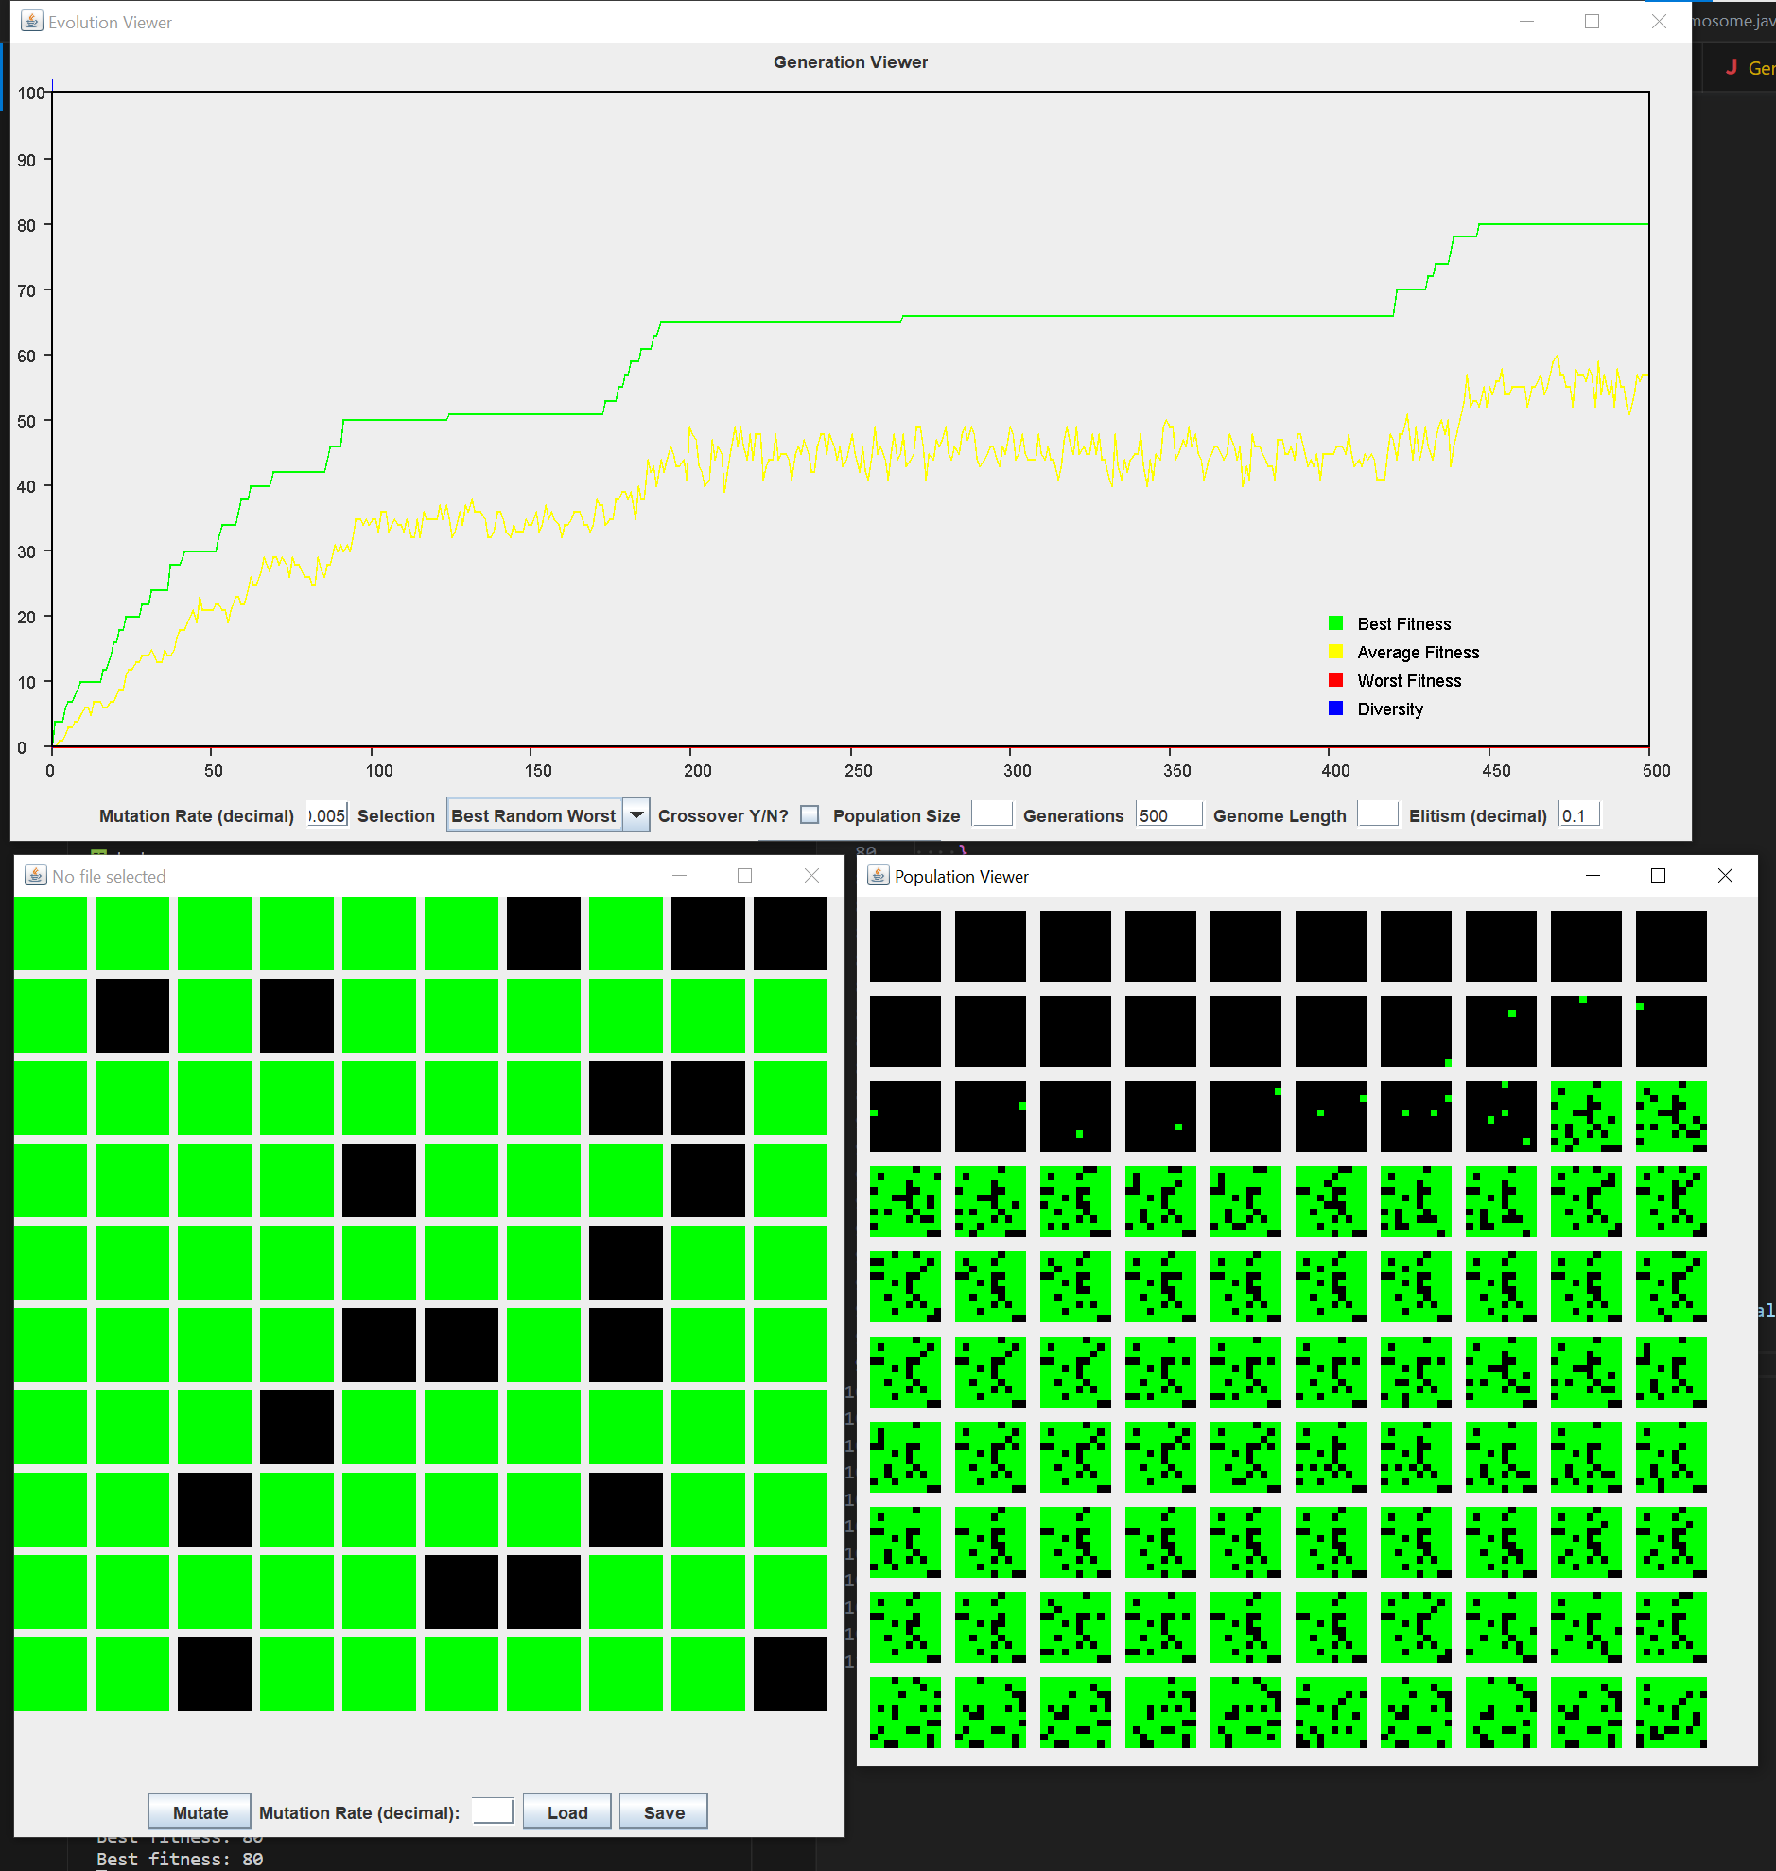

|  |  |  |  |  |  |  |  |  |  |  |
| --- | --- | --- | --- | --- | --- | --- | --- | --- | --- | --- |
| run # | 1 | 2 | 3 | 4 | 5 | 6 | 7 | 8 | 9 | 10 |
| gens | *500* | *500* | *500* | *500* | *500* | *500* | *500* | *500* | *500* | *500* |
| max fit. | *66* | *66* | *80* | *80* | *68* | *66* | *65* | *80* | *68* | *66* |

1. **What if anything you can conclude and anything you learned or affirmed by doing so?**

*See conclusions for Experiment 7.*

**Experiment 7 Report**

1. **An explanation of the experiment (including parameters used)**

|  |  |
| --- | --- |
| *population size:* | *100* |
| *mutation rate:* | *0.5%* |
| *crossover method:* | *false* |
| *chromosome length:* | *100* |
| *selection method:* | *Truncation* |
| *max generations:* | *500* |
| *elitism:* | *10%* |
| *fitness method:* | *Troughs* |

1. **A hypothesis (might just be a guess)**

It cannot reach as high a fitness score as the best random worst method with this fitness landscape.

1. **Description of the results including plots (or a table of results)**

Like best random worst, the fitness increases by steps and then reaches certain plateaus before potentially climbing another step. However, the truncation method cannot navigate this landscape with troughs as well as the best random worst method as shown in the lower best fitness scores, yet, its average and worst fitness do evolve better than best random worst.

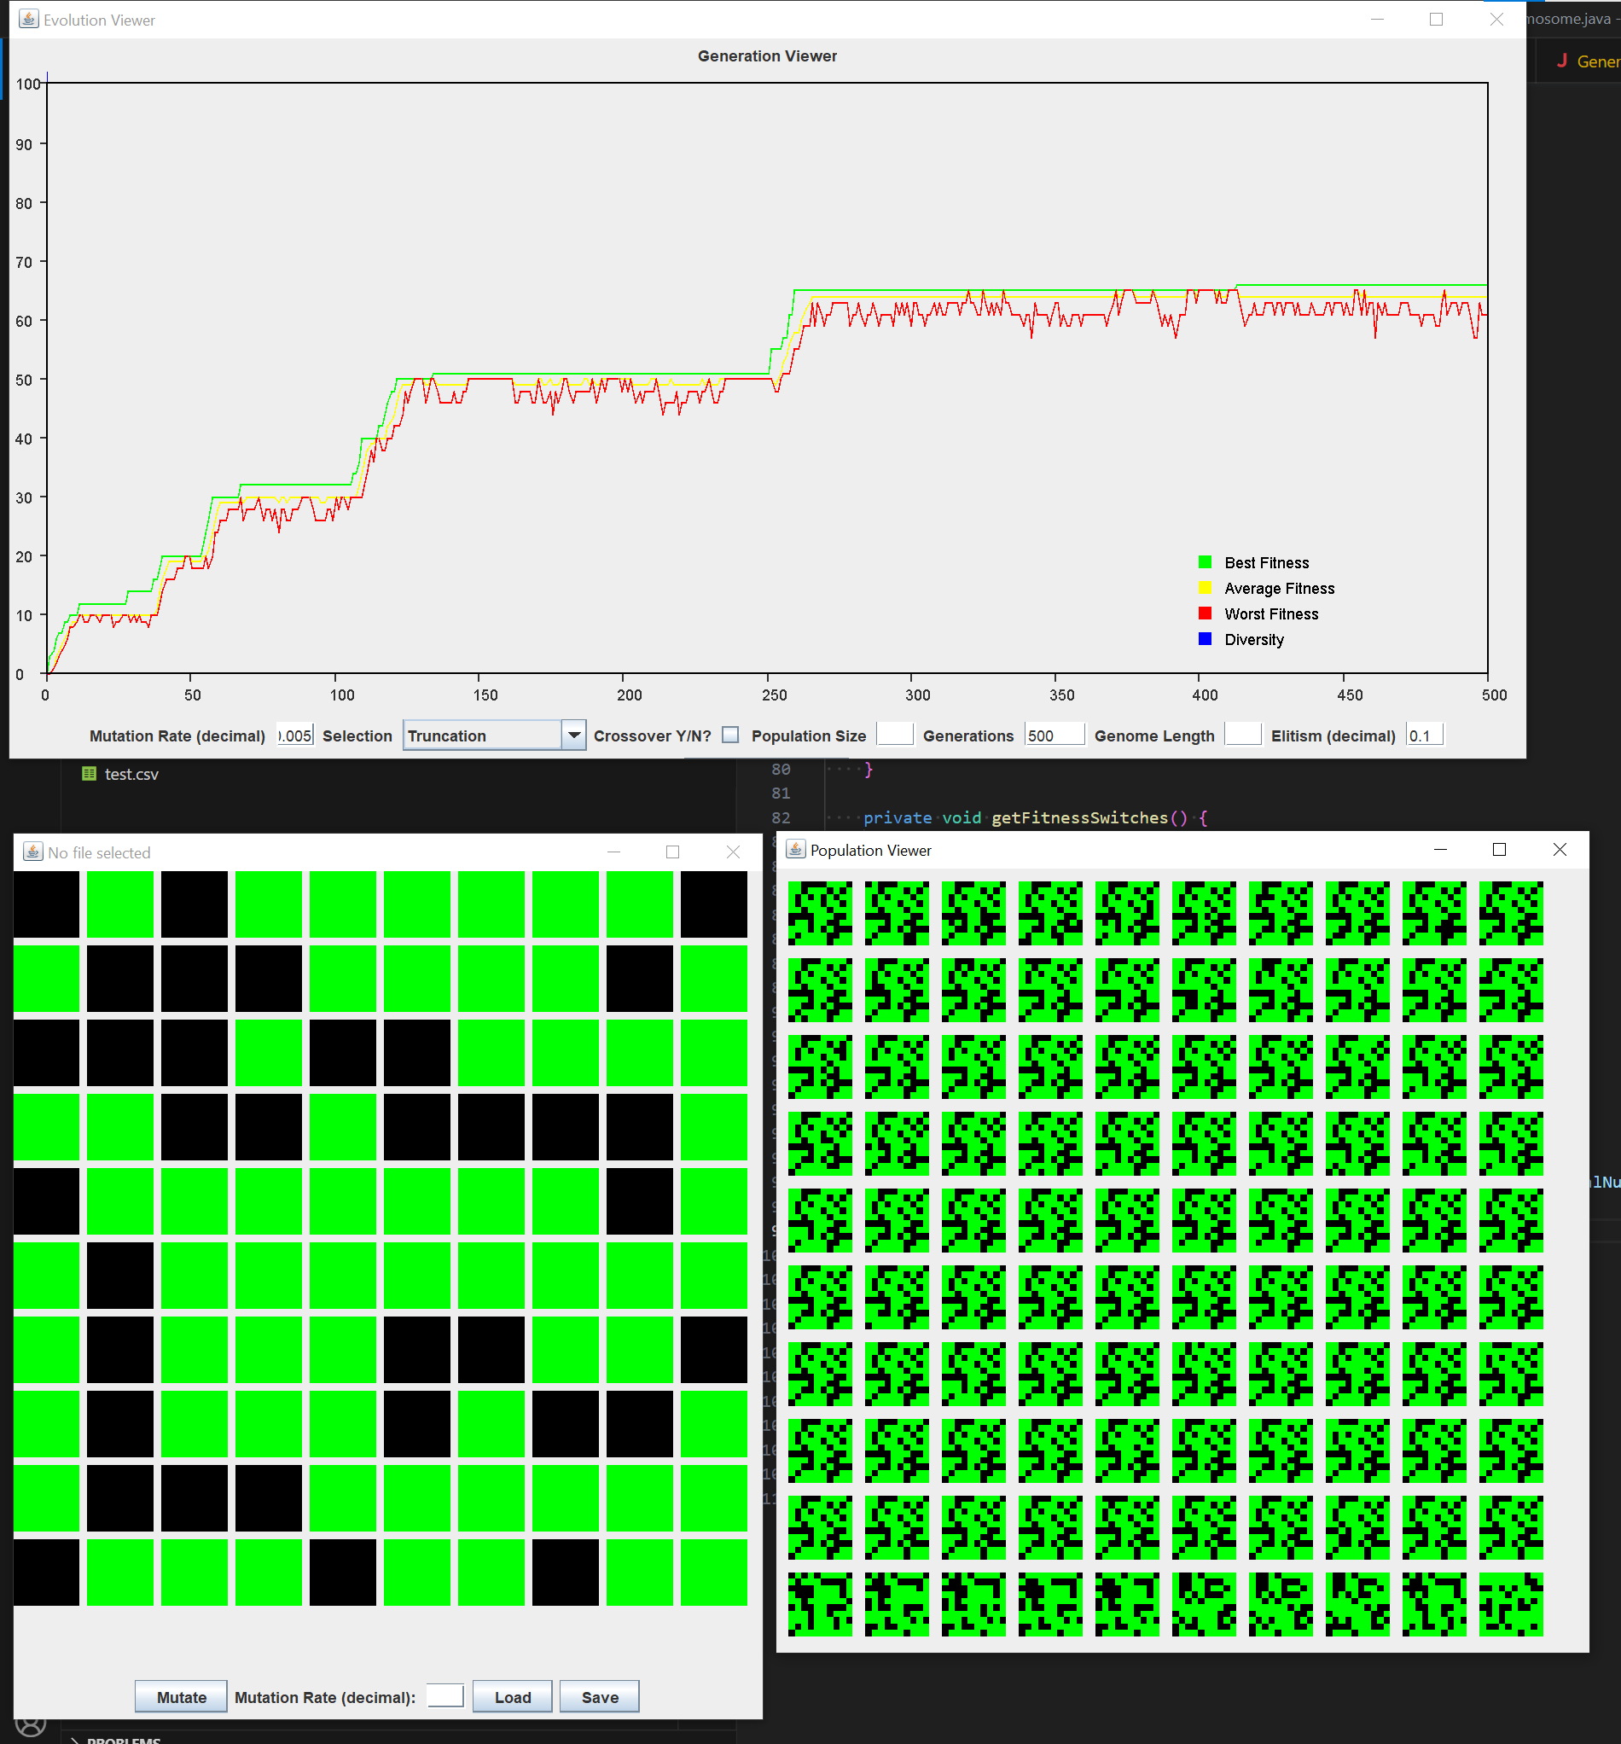

|  |  |  |  |  |  |  |  |  |  |  |
| --- | --- | --- | --- | --- | --- | --- | --- | --- | --- | --- |
| run # | 1 | 2 | 3 | 4 | 5 | 6 | 7 | 8 | 9 | 10 |
| gens | *500* | *500* | *500* | *500* | *500* | *500* | *500* | *500* | *500* | *500* |
| max fit. | *53* | *53* | *51* | *59* | *65* | *53* | *65* | *51* | *65* | *66* |

1. **What if anything you can conclude and anything you learned or affirmed by doing so?**

*In comparison to Experiment 6, the Best Random Worst selection method does a better job at getting over troughs in fitness, allowing overall higher fitness. Specifically, in this situation, the Truncation selection method clearly demonstrates one of its failings, specifically that there are fitness peaks that it cannot overcome. Best Random Worst is one step closer to overcoming that boundary, and therefore one step closer to real world situations.*

**Experiment 8 – Reproducing Research Paper Results**

1. **An explanation of the experiment (including parameters used)**

We added a third gene type and added a clause to mutation to give the third gene a certain percent chance of choosing a 1 gene or the third gene. Graphics wise, the graph will display the percentage of each allele in best chromosome. A timer slowly decreases the mutation rate over time.

|  |  |
| --- | --- |
| *population size:* | *1000* |
| *mutation rate:* | *decreasing by 5% each time starting at 1%*  *Ex. 1% - 0.95% -0.9025%...* |
| *crossover method:* | *false* |
| *chromosome length:* | *100* |
| *selection method:* | *Truncation* |
| *max generations:* | *200* |
| *elitism:* | *0%* |
| *fitness method:* | *All 1s* |

1. **A hypothesis (might just be a guess)**

The percentages of correct alleles, incorrect alleles, undecided alleles will all reach a certain constant value in the long run. However, the value of correct allele percentage will be greater than that of undecided alleles, and the undecided allele percentage will be greater than that of the incorrect alleles.

1. **Description of the results including plots (or a table of results)**

The result was not quite as predicted. Before most of the trials were able to reach a constant value, they already reached the termination condition of 100% fitness. However, from trial 2, we can see that the values do come to a plateau if the chromosomes evolved in a less ideal way. Also, while the correct allele percentage is the highest value, incorrect allele percentage exceeds that of the undecided alleles, contrary to the hypothesis.

|  |  |  |  |  |  |  |  |  |  |  |
| --- | --- | --- | --- | --- | --- | --- | --- | --- | --- | --- |
| run # | 1 | 2 | 3 | 4 | 5 | 6 | 7 | 8 | 9 | 10 |
| gens | 112 | >200 (plateaued) | 99 | 86 | 114 | 111 | 93 | 84 | 131 | 135 |

1. **What if anything you can conclude and anything you learned or affirmed by doing so?**

First, we tried to use the exact parameters used in the research paper: population size of 1000, 50 generations, genome length of 20. However, below is the result we got.

The graph deviates more from that of the research paper than our later modified parameters. The incorrect allele percentage is significantly higher than that of the correct or undecided allele. The main reason for this is probably that our algorithm is more suited for a longer genome length like 100. With 20, the chromosomes are not given enough time to evolve before reaching a plateau.

With our modified parameters, we were able to get better results. Yet, our undecided allele percentage reaches 0 very soon after the start of the evolution process. This is due to the learning method that we created. The author of the research paper used a more complex learning simulation than us. For us, for each evolution, the undecided alleles were given a 10% chance of locking into the correct gene. Thus, the undecided alleles have a good chance of changing into correct alleles in the long term, which is different than the learning method used in the research.